**Introduction**

The Apache JMeter™ application is open source software, a 100% pure Java application designed to load test functional behavior and measure performance. It was originally designed for testing Web Applications but has since expanded to other test functions.

## Installation

Note : Requires Java 6 or later

To download JMeter we have to access the following page :

<http://jmeter.apache.org/download_jmeter.cgi>

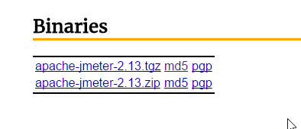

Unzip apache-jmeter-X.XX.zip to c:\jmeter ( For example )

## Running JMeter

To run JMeter, run the jmeter.bat (for Windows) or jmeter (for Unix) file. These files are found in the bin directory.

* jmeter.bat - run JMeter (in GUI mode by default)
* jmeterw.cmd - run JMeter without the windows shell console (in GUI mode by default)
* jmeter-n.cmd - drop a JMX file on this to run a non-GUI test
* jmeter-n-r.cmd - drop a JMX file on this to run a non-GUI test remotely
* jmeter-t.cmd - drop a JMX file on this to load it in GUI mode
* jmeter-server.bat - start JMeter in server mode
* mirror-server.cmd - runs the JMeter Mirror Server in non-GUI mode
* shutdown.cmd - Run the Shutdown client to stop a non-GUI instance gracefully
* stoptest.cmd - Run the Shutdown client to stop a non-GUI instance abruptly

1. Create a Thread Group

Thread group elements are the beginning points of any test plan. All controllers and samplers must be under a thread group.

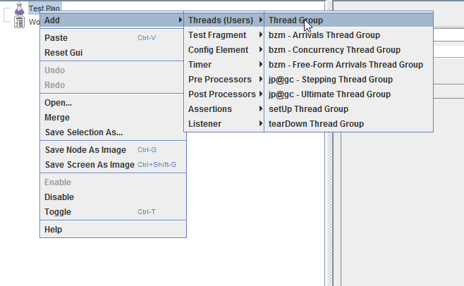

The controls for a thread group allow you to:

Set the number of threads ( Each thread will execute the test plan in its entirety and completely independently of other test threads. Multiple threads are used to simulate concurrent connections to your server application. )

Set the ramp-up period ( The ramp-up period tells JMeter how long to take to "ramp-up" to the full number of threads chosen. )

Set the Loop Count ( number of times to execute the test )

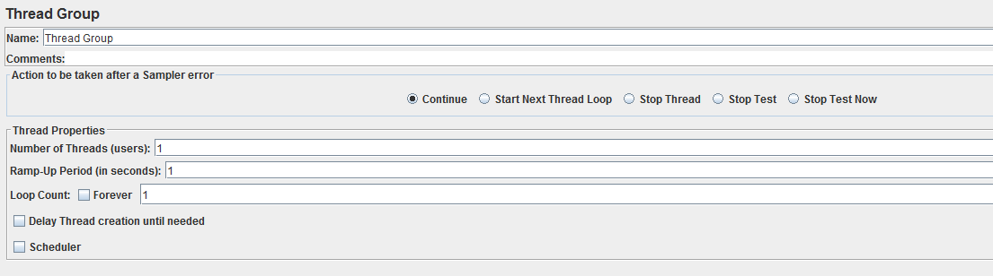

## Browser Setup to use JMeter Proxy

* 1. Start Firefox ( For example ) , but do not close JMeter.
  2. From the tool bar, click “Edit -> Preferences” (or “Tools > Preferences”). This should bring up the options.
  3. Select the “Advanced” tab, and “Network”
  4. Click “Settings” button near the bottom.
  5. On the new pop-up, check “Manual proxy configuration”. The address and port fields should be enabled now.
  6. Proxy HTTP – enter “localhost”
  7. Port - enter “7070”
  8. Check “Use this proxy server for all protocols”

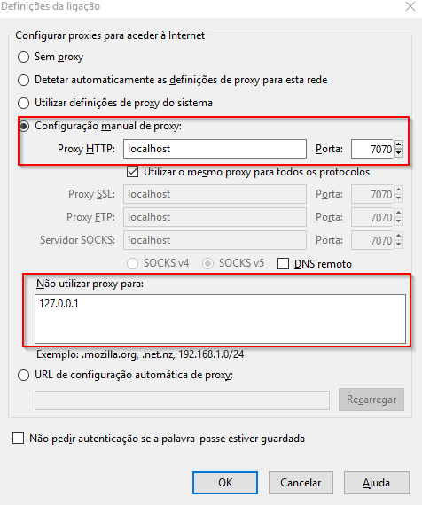

In JMeter – WorkBench add ( HTTP(S) Test Script Recorder )

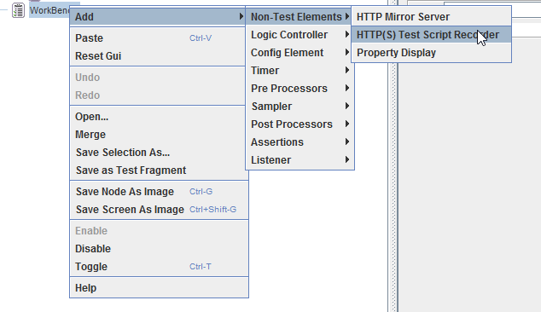

Into HTTP(S) Test Script Recorder , change parameters of “Global Settings” , HTTPS Domains and Target Controller

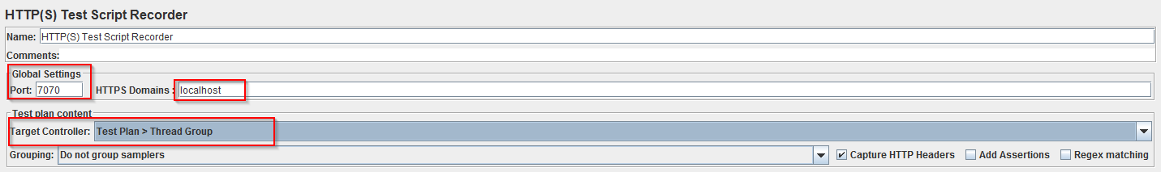

Press Start



With the browser, in the “Address” bar at the top, enter http://localhost:8080/pentaho/Login” and hit the “enter” key

Example :

1. Login
2. Browse Files
3. Open Home\Admin\sate.cda

Close browser and bring up the JMeter window

Press Stop



Everything is recorded in Test Plan \ Thread Group

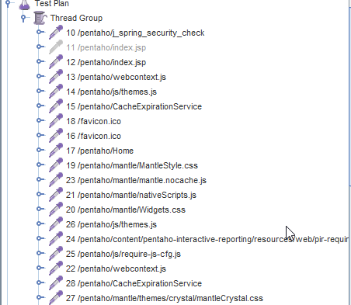

For example, if we need to call service “doQuery”

1. We can delete everything except :

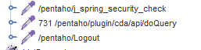

/pentaho/j_spring_security_check ( Login in the platform )

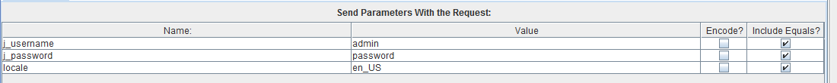

/pentaho/plugin/cda/api/doQuery

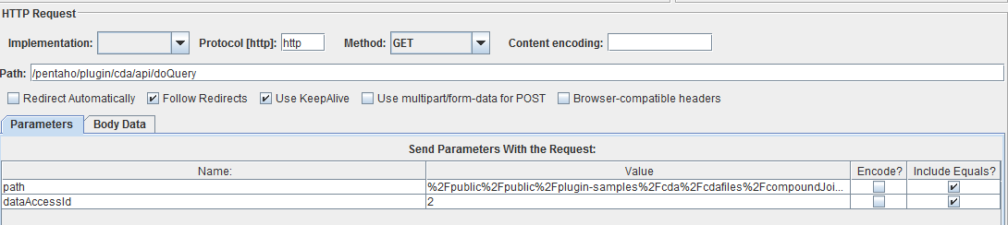

/pentaho/logout



To see what services we have, access for example this address :

<https://github.com/webdetails/cda/blob/master/pentaho/src/main/java/pt/webdetails/cda/CdaUtils.java>

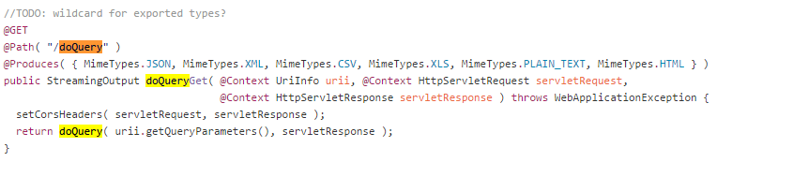

## Create HTTP Cookie Manager

The cookie manager stores and sends cookies just like a web browser

In Pentaho Solution we have an HTTP Request and the response contains a cookie, so, the Cookie Manager automatically stores that cookie and will use it for all future requests to that particular web site.

To Add this :

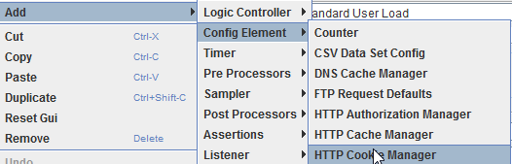

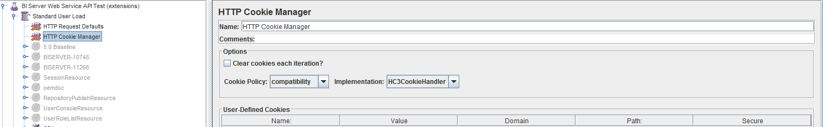

## Create HTTP request defaults

This element lets you set default values that your HTTP Request controllers use. For example, if you are creating a Test Plan with 8080 HTTP Request controllers and all of the requests are being sent to the same server, you could add a single HTTP Request Defaults element with the "Server Name or IP" field filled in.

To add this :

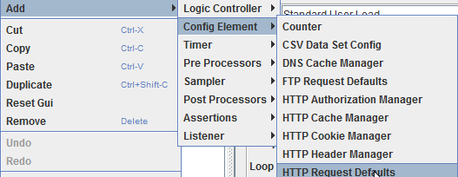.

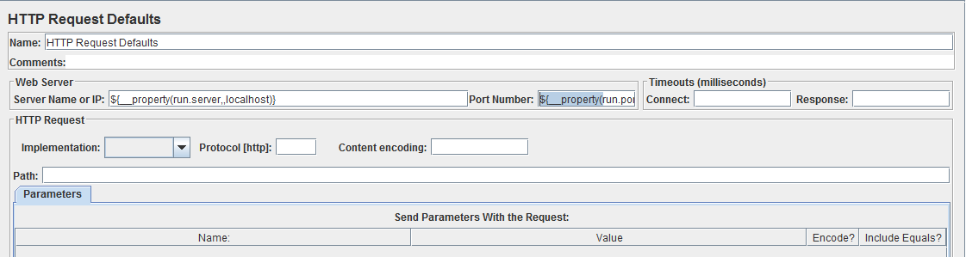

Server Name or Ip : ${__property(run.server,,localhost)}

Port Number : ${__property(run.port,,8080)}

## Add a Listener

A listener is a component that shows the results of the samples. The results can be shown in a tree, tables, graphs or simply written to a log file. To view the contents of a response from any given sampler, add either of the Listeners "View Results Tree" or "View Results in table" to a test plan. To view the response time graphically, add graph results.

To Add this

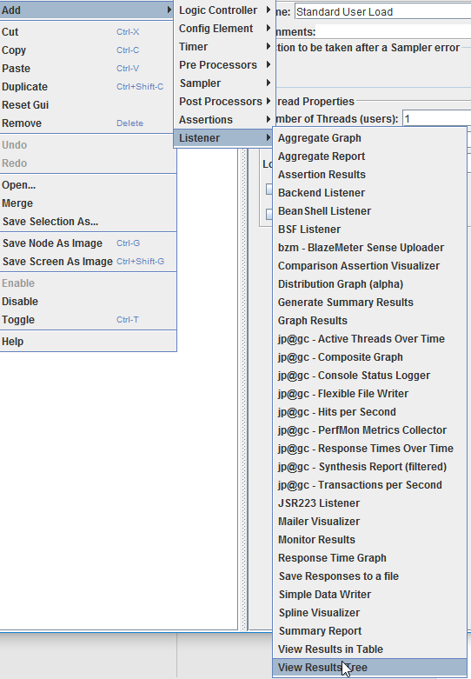

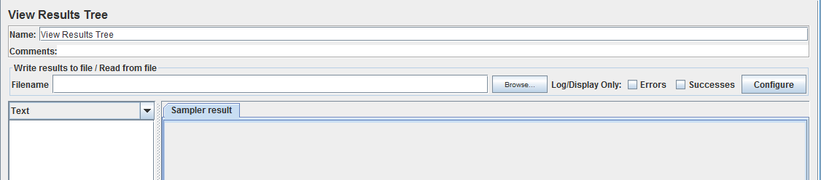

## How to Play

Press Start



Then we can see the results in added listener.

If we access the listener , we can see the request msg and response data

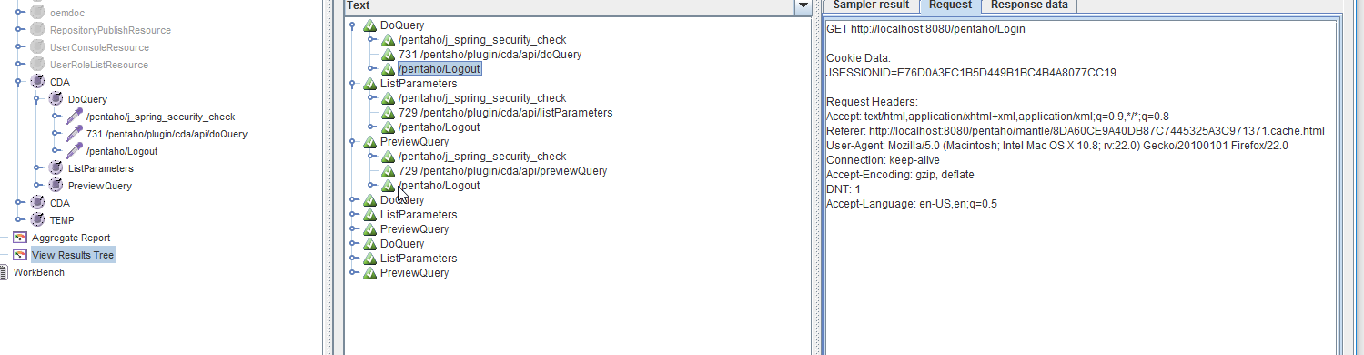

Note : we can change the format ( response data )

Example :

* HTML

